

Experiment No.7

Title: Execution of ETL process

Batch: B2 Roll No.: 1914078 Experiment No.:7

Aim: To execute ETL process.

___________________________________________________________________________

Resources needed: Different RDBMS such as MySQL, Postgres and Excel, CSV,
Rapidminer 5.3
___________________________________________________________________________

Theory

Extract, Transform, Load (ETL) refers to a process in database usage and especially in data warehousing. Data extraction is where data is extracted from homogeneous or heterogeneous data sources; data transformation where the data is transformed for storing in the proper format or structure for the purposes of querying and analysis; data loading where the data is loaded into the final target database, more specifically, an operational data store, data mart, or data warehouse.

By using an established ETL framework, one may increase one's chances of ending up with better connectivity and scalability. A good ETL tool must be able to communicate with the many different relational databases and read the various file formats used throughout an organization. ETL tools have started to migrate into Enterprise Application Integration, or even Enterprise Service Bus, systems that now cover much more than just the extraction, transformation, and loading of data. A common use case for ETL tools include converting CSV files to formats readable by relational databases. A typical translation of millions of records is facilitated by ETL tools that enable users to input csv-like data feeds/files and import it into a database with as little code as possible. ETL tools in most cases contain a GUI that helps users conveniently transform data, using a visual data mapper, as opposed to writing large programs to parse files and modify data types


RapidMiner provides data mining and machine learning procedures including: data loading and transformation (Extract, transform, load (ETL)), data preprocessing and visualization, predictive analytics and statistical modeling, evaluation, and deployment. RapidMiner is written in the Java programming language. RapidMiner provides a GUI to design and execute analytical workflows. Those workflows are called “Processes” in RapidMiner and they consist of multiple “Operators”. Each operator performs a single task within the process, and the output of each operator forms the input of the next one. Alternatively, the engine can be called from other programs or used as an API. Individual functions can be called from the command line. RapidMiner provides learning schemes, models and algorithms and can be extended using R and Python scripts

__________________________________________________________________________

Procedure:
Create the workflow in RapidMiner to Perform following tasks:

- Extract data from 2 to 3 heterogeneous sources such as excel, MYSQL, Postgres etc.
- Integrate the data from various sources.

- Apply at least three different transformations to standardize and clean the data.

________________________________________________________________________

Results: (Program printout with output)
Added 2 datasets about students with one dataset having one attribute missing to the repository.

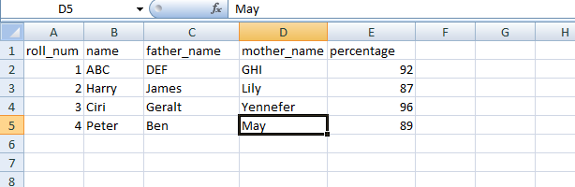
One is an excel dataset and saved it as DB_1.
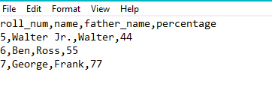
One is a csv file where “mother_name” attribute is missing and saved it as “DB_2”.
Adding an empty attribute “mother_name” to DB_2.
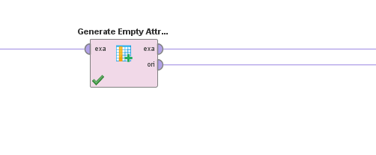

Using Extract Aggregate
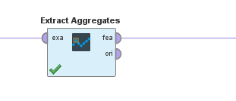
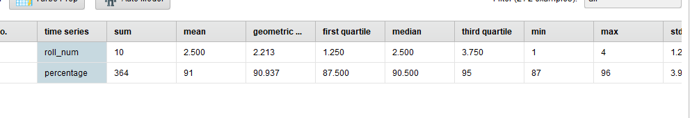
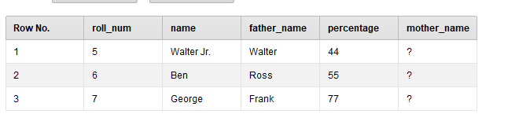
And stored it named “Modified_DB2”.
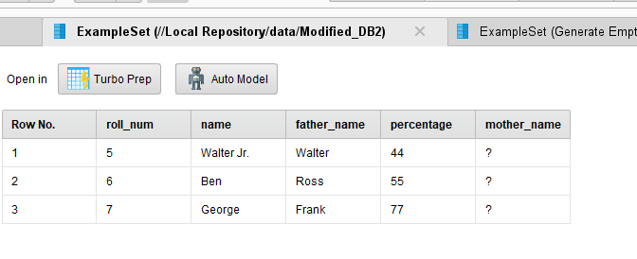
Now that both table have matching attributes, it’s possible to append both the tables
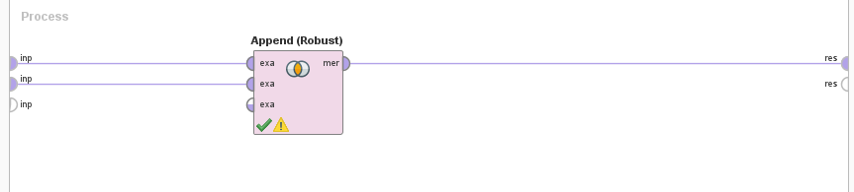
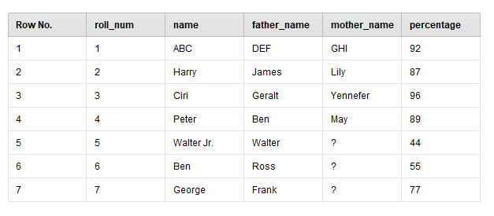
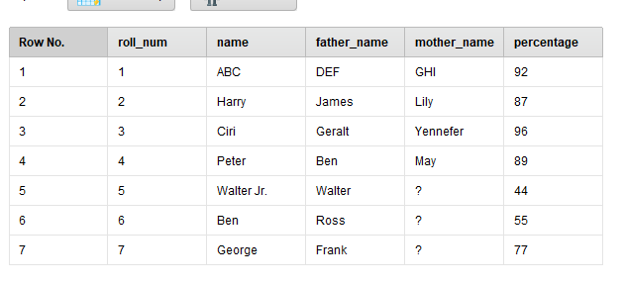

And saved it named “Appended_DB”.

Adding “Status” attribute showing pass or fail status of student based on percentage
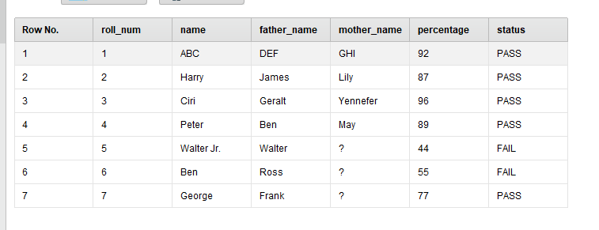

Outcomes:
Understanding of data warehouse andits multi-dimensional modeling

Conclusion: (Conclusion to be based on the outcomes achieved)

Learned about ETL processes using RapidMiner software and executing them.

Grade: AA / AB / BB / BC / CC / CD /DD

Signature of faculty in-charge with date
___________________________________________________________________________
References:

- Paulraj Ponniah, “Data Warehousing: Fundamentals for IT Professionals”, Wiley
India

- http://docs.rapidminer.com/

Page No:

